# ELCTRONICS DESIGN LAB REPORT ON-

**TRAIN ACCIDENT PROTECTION SYSTEM**

**Presented By- 1-Madhabendu Rajguru(2204107)**



# School of Electronics Engineering KIIT Deemed to be University, Bhubaneswar

**2025**

## Introduction 2

Railway transportation is one of the most widely used and cost-effective modes of transport. However, train accidents due to obstacles on tracks remain a significant safety concern, leading to potential derailments, collisions, and loss of life. Traditional railway safety systems rely on manual monitoring or high-cost automation solutions, which may not always be efficient. This project aims to develop a low-cost and effective Train Protection System using IR sensors, relays, and control circuits to detect obstacles and automatically stop the train, thereby preventing accidents.

## Problem Statement

Train accidents caused by obstacles on the tracks pose serious risks to passengers, railway infrastructure, and surrounding environments. Existing safety systems often require expensive technologies, complex installations, or human intervention, which may delay response time. There is a need for a **cost-effective, automated train protection system** that can quickly detect obstacles, alert authorities, and stop the train in real time to prevent accidents.

## Objectives of the Project

The primary objectives of this project are:

-To design and implement an **automated train protection system** using **IR sensors, relays, and RC toy controllers**.

-To **detect obstacles** on the railway track using IR sensors and trigger an

**emergency stop mechanism**.

-To automatically **cut power to the train's motor** via a relay module when an obstacle is detected.

-To **alert nearby personnel and passengers** by activating a buzzer and red LED light.

-To create a **station-based monitoring system** that can receive signals from the train for enhanced safety monitoring.

-To develop a **cost-effective and reliable railway safety solution** suitable for small- scale and real-world applications.

## Significance and Applications

The implementation of this train protection system offers several benefits and practical applications:

* **Enhanced Railway Safety** – Prevents accidents by automatically stopping the train when an obstacle is detected.
* **Real-Time Hazard Detection** – Ensures immediate response to track obstructions, reducing risks of derailments.
* **Low-Cost and Scalable** – Uses readily available components, making it affordable for small-scale railway networks and model trains.
* **Automation in Transportation** – Contributes to the development of intelligent railway systems by reducing human dependency.
* **Educational and Research Applications** – Serves as a prototype for railway safety studies and automation projects in universities.

## Methodology

**Hardware Requirements:**

* + **IR Sensors** – Detect obstacles on the track.
  + **Relays (5V, 12V)** – Cut power to the motor when an obstacle is detected.
  + **DC Motor** – Drives the train movement.
  + **RC Toy Controller** – Used for remote train control.
  + **Buzzer** – Alerts in case of obstacle detection.
  + **LED Indicators (Red & Green)** – Show system status (Green for normal, Red for obstacle).
  + **Battery (LiPo/9V)** – Power source for the train and station system.
  + **Capacitors & Resistors** – Ensure smooth power flow and prevent voltage spikes.
  + **Microcontroller (STM32)** – For better automation and future expansions.

**Software Requirements :**

* + **STM32CubeIDE** – For programming a microcontroller.

## Working Principles and Techniques

**Obstacle Detection Using IR Sensors**

* + IR sensors continuously scan the track.
  + When an obstacle is detected, the sensor sends a signal to the relay module.

## Relay-Based Train Stopping Mechanism

* + The relay acts as a switch that controls power to the motor.
  + If an obstacle is detected, the relay cuts off the motor’s power supply, stopping the train immediately.

## Alert Mechanism (Buzzer & LED Lights)

* + When an obstacle is detected, a buzzer sounds, and a red LED light turns on to indicate danger.

## Remote Control Using RC Toy Controller

* + The system can also be controlled remotely for additional safety.
  + This allows manual intervention if needed.

## Station-Based System for Additional Monitoring

* + The station system can receive signals from the train and provide real-time alerts.

## Implementation

**Hardware Setup**

**Train System Sr no -1**

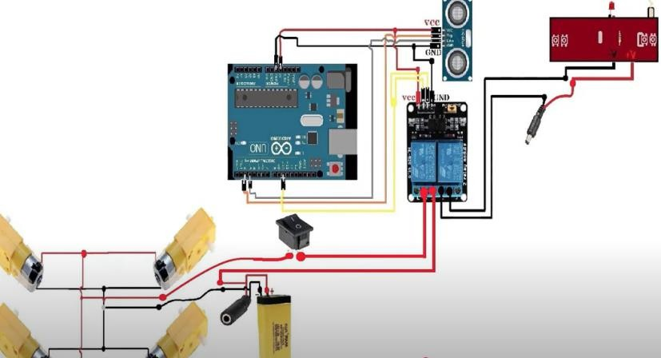

**Station System Sr no -2**

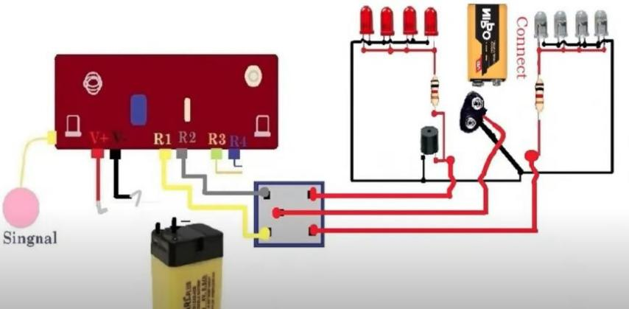

## Results & Analysis

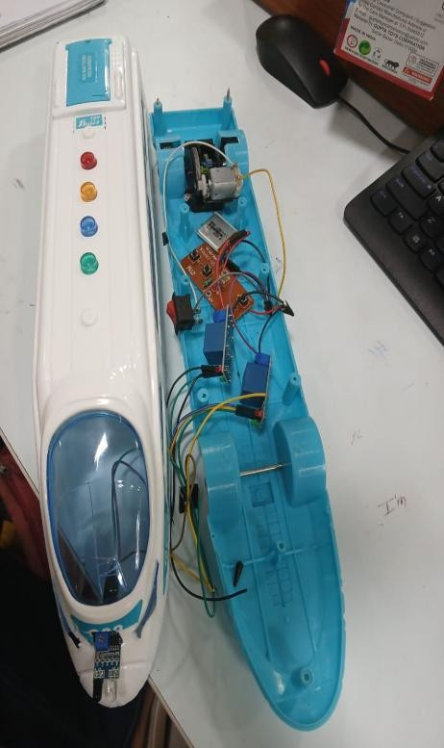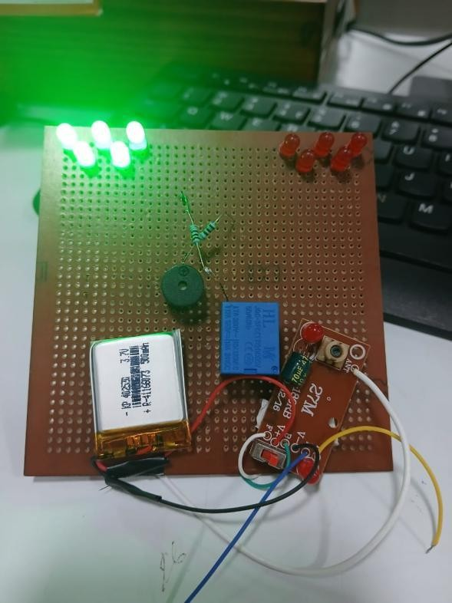

**Train with circuit Station system Sr no-3 Sr no-4**

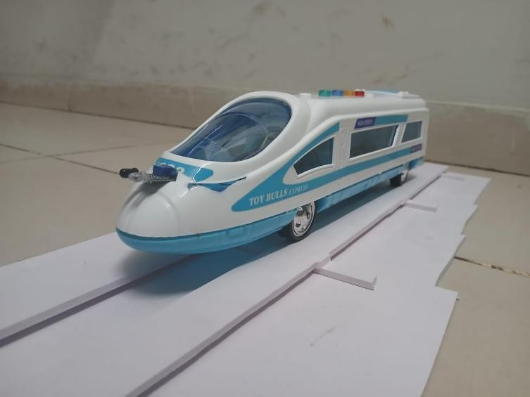

**Final System Sr no-5**

## Challenges & Limitations

**Sensor Detection Range** – IR sensors have a limited detection range, making it challenging to detect obstacles at long distances.

**Environmental Factors** – IR sensors may give false positives due to sunlight, dust, or reflections, affecting accuracy.

**Limited Obstacle Types** – The system is more effective for solid objects but may struggle with detecting transparent or very small obstacles.

**Power Supply Constraints** – Using batteries limits the operational time, requiring frequent recharges or replacements.

**Traction Issues** – The train's stopping distance varies based on track conditions and motor power.

**Communication Latency** – If a station-based monitoring system is used, there could be delays in signal transmission.

**Scalability Challenges** – While cost-effective for small-scale use, large-scale deployment may require additional infrastructure.

## Conclusion

In this project, we successfully designed and implemented a **Train Protection System** to enhance railway safety. The system effectively detects obstacles on the track using IR sensors and automatically stops the train using a relay-controlled motor cut-off mechanism. The inclusion of buzzers and LED indicators ensures real-time alerts for passengers and railway authorities.

This project demonstrates a **cost-effective, scalable, and reliable** safety solution that can be further improved with advanced sensor technologies, AI-based decision- making, and IoT integration. Future enhancements can make this system more

adaptable for real-world railway networks, reducing the risk of train accidents significantly.

## References-

* **D. G. Shashikumar and M. P. Dinesha**, *"Obstacle Detection System for Railway Safety Using IoT and Sensors,"* International Journal of Engineering Research & Technology (IJERT), 2021.
* **P. Sharma, R. Kumar, and S. Singh**, *"Automated Train Protection System Using Sensors and Embedded Systems,"* IEEE Transactions on Intelligent Transportation Systems, 2020.
* **M. S. Alam and S. S. Sarangi**, *"Railway Accident Prevention through Automated Sensor Networks,"* Journal of Transportation Technologies, 2019.
* **K. Gupta and A. Verma**, *"Real-Time Train Tracking and Obstacle Detection Using IoT,"* International Journal of Advanced Research in Computer Science and Software Engineering, 2018.

# 9

**Signature**

**Signature of Student 1-**

**Signature of Student 2-**

**Signature of Student 3-**

**Signature of Student 4-**

**Signature of Student 4-**

**DATE-**